

The Arab American University

Faculty of Engineering and Information Technology

Engineering Project Management (11071514)

iStudent E-learning Platform

  - Prepared by:
  - Mohammad Abu Malash - 201911801
  - Moath Abu Malash – 201912230
  - Hassan Braik – 201711446
  - Basil Salahat – 201811775

  - Instructor
  - Eng Mohammad Tuffaha

  - June 2023 © Arab American University – Palestine

Table of Contents

List of Tables

Introduction

Similar to the proverb that states "hope is born from the womb of suffering," new start-ups embody the same essence. They are born from ideas that provide solutions to real problems, addressing the needs of many people, and making information more accessible, saving time and effort for everyone involved. Our venture focuses on creating an online platform specifically designed for Tawjihi students. It offers a wide array of resources aimed at educating and training students, ensuring their comprehension of subjects and topics, and enabling them to achieve the best possible results. This is particularly important in light of the ongoing Coronavirus pandemic, which has imposed travel bans and restrictions, making it challenging for students to move freely within the country, or even in certain regions.

Chapter One
Project Pre-Initiation
&
Initiation

Project Pre-Initiation and Initiation

Overview

During the period of prolonged school closures caused by the Covid-19 virus, students, especially high school students, have faced significant challenges in accessing educational assistance and completing their studies. Recognizing the critical importance of this stage in a learner's life, our project aims to establish an interactive and electronic learning platform. This platform will provide students with all the necessary resources and support they need to excel in their Ministerial exams.
Even without the presence of the Covid-19 pandemic, our project has the potential to continue its impact. By offering comprehensive video explanations of lessons and providing information in a direct and easily accessible manner, our platform addresses the fundamental needs of students. Thus, even under normal circumstances, the project's approach remains relevant and valuable in ensuring students' successful progression and understanding of their educational materials.

The scope, time, and cost constraints for the project

- Scope:
Our project aims to offer a well-structured and user-friendly learning experience by providing recorded lessons for each subject, organized according to the semester, unit, and lesson. Students can easily access these lessons and study at their own pace. Additionally, we will conduct weekly group classes where students can ask questions and engage in collaborative learning. To further support students' individual needs, we will offer the option to schedule online sessions with our qualified teachers for additional guidance in any subject, with a corresponding fee. This comprehensive approach ensures that students have access to high-quality educational resources and personalized assistance to enhance their understanding and excel academically.
- Time:
The completion of our project involves a two-month timeline for class preparation and an additional two months for platform construction. In summary, the entire project is expected to be finished within a timeframe of approximately four months.
- Cost:
The estimated total cost of the project, encompassing the acquisition of instructional materials, platform development, and staff salaries for the initial two-month period, is approximately 400,000 shekels. It's worth noting that while there is an existing electronic platform owned by the Palestinian Ministry of Education, our proposed platform aims to simplify the student's journey and provide easier access to necessary information, thereby enhancing their ability to achieve their objectives.

Business case

Business Case for iStudent E-learning Platform
Date: 25 May 2023
Prepared by: Basil Salahat
- Introduction/ Background
Our platform is dedicated to supporting students and enabling them to achieve high academic performance. We provide a comprehensive range of resources, including video content, to facilitate easy access to information. Moreover, we connect students with specialized teachers who have a genuine interest and expertise in the subject matter. By offering these valuable resources and connections, our platform aims to empower students and propel them towards attaining excellent academic results. Our ultimate goal is to facilitate student success and foster their academic advancement.
2.0 Business Objective
Our platform's objectives revolve around catering to the needs of high school students by offering them a convenient way to comprehend their study materials without the need to leave their homes or spend time searching for information elsewhere. The project emphasizes efficiency by providing quick access to relevant resources. Moreover, our platform enables students to take short online exams and receive immediate results, enhancing their learning experience and providing valuable feedback in real-time. By combining accessibility, convenience, and instant feedback, our platform aims to streamline the learning process for high school students and optimize their educational outcomes.
3.0 Current Situation and Problem/Opportunity Statement
While acknowledging the presence of a similar platform offered by the Ministry of Education and Higher Education, we aim to distinguish ourselves through the unique content we provide to students. Our platform will offer fresh explanations and innovative teaching methods, supplementing the existing resources. However, in order to gain the trust of both teachers and students, it is crucial to secure the support of the Ministry of Education. By establishing an official partnership with the ministry, we can collaborate with teachers and gain their endorsement, ensuring that students can have confidence in the quality and reliability of our platform. We recognize the importance of working in harmony with the education authorities to create a trusted and effective learning environment for the students we serve.
4.0 Critical Assumption and Constraints
In order to access student and instructor data, our platform needs to establish communication with the Ministry of Education's server. This connectivity allows us to facilitate video conferences with students, enabling us to create interactive classrooms and train professors on effectively utilizing our website for educational purposes. We also recognize the significance of leveraging student testimonials to promote our platform's effectiveness in studying and its overall benefits. To expedite the project's launch, we prioritize the efficient production of courses and videos while ensuring the highest quality explanations are captured. This approach enables us to promptly introduce the project to the public, ensuring a comprehensive and impactful learning experience for students.
5.0 Analysis of Option and Recommendation
- Our initial focus will be on developing a streamlined website that allows students to submit tests for specific subjects or the entire curriculum. The website's primary functionality will be limited to facilitating exam submissions.
- Additionally, we will provide a comprehensive collection of recorded videos on the platform. These videos will be categorized based on subject specialties, allowing students to easily access and listen to recorded lectures and course materials.
- As part of our long-term plans, we aim to develop an advanced platform that goes beyond basic functionalities. This comprehensive platform will include interactive quizzes, a wide range of educational videos, and the capability for students and instructors to connect and engage in interactive online meetings. This integrated approach will foster an interactive and immersive learning experience for students, providing them with the tools necessary to excel in their studies.
6.0 Preliminary Project Requirements
Not found
7.0 Budget Estimate and Financial Analysis
Not found
8.0 Schedule Estimate
The estimated timeline for project completion is approximately four months, although there is some flexibility in the schedule to accommodate any unforeseen circumstances or adjustments. Furthermore, we assume that the newly developed system will have a minimum useful life of three years. This assumption ensures that the system will continue to serve its intended purpose effectively and provide long-term benefits to the students and users of the platform.
9.0 Potential Risks
The project entails various risks that need to be addressed. The primary risk involves a potential lack of interest from both students and teachers in adopting and utilizing our platform. User engagement and input play a critical role in populating the system with relevant information and unlocking the full potential benefits of the platform.
There are also technical risks associated with selecting the appropriate software for system search capabilities, ensuring robust security measures, and implementing seamless payment processing. These technical aspects require careful consideration and mitigation to minimize potential issues and vulnerabilities.
However, the most significant risk lies in gaining the trust of our target audience. Building trust among students, teachers, and other stakeholders is essential for the success of our project. We must establish credibility, reliability, and demonstrate the value and effectiveness of our platform to overcome this risk and gain the confidence of our intended users. Implementing transparency, maintaining open communication, and consistently delivering on our promises will be key in building trust and fostering widespread adoption of our platform.
10.0 Exhibits
Exhibit A: Financial Analysis.

Project’s Stakeholders Register

Stakeholder Register for iStudent E-learning Platform
Prepared by: Moath Abu Malash
Date: 23/5/2023
Name | Position | Internal/  External | Project Role | Contact Information
Ministry | Sup owner | external | Sponsor | Ministry@gmail.com
Mohammad Abu Malash | CEO | Internal | Owner | Mohammad@learn-pal.com
Moath Abu Malash | Manager | Internal | Project manager | Moath @learn-pal.com
Basil Salahat | Leader | Internal | Team Coordinator | Basil@learn-pal.com
Hassan Braik | Procurement Manager | external | Advisor | Carlos@learn-pal.com
Lojain Ahmad | Team member | Internal | Team Member | Lojain @learn-pal.com
Sarah Salahat | Team member | Internal | Team Member | sarah@learn-pal.com
Table 1Stakeholder Register for E-learning Platform

Project Organizational Chart

Organizational Chart for iStudent E-learning Platform
Prepared by: Mohammad Abu Malash
Date:26 May 2023
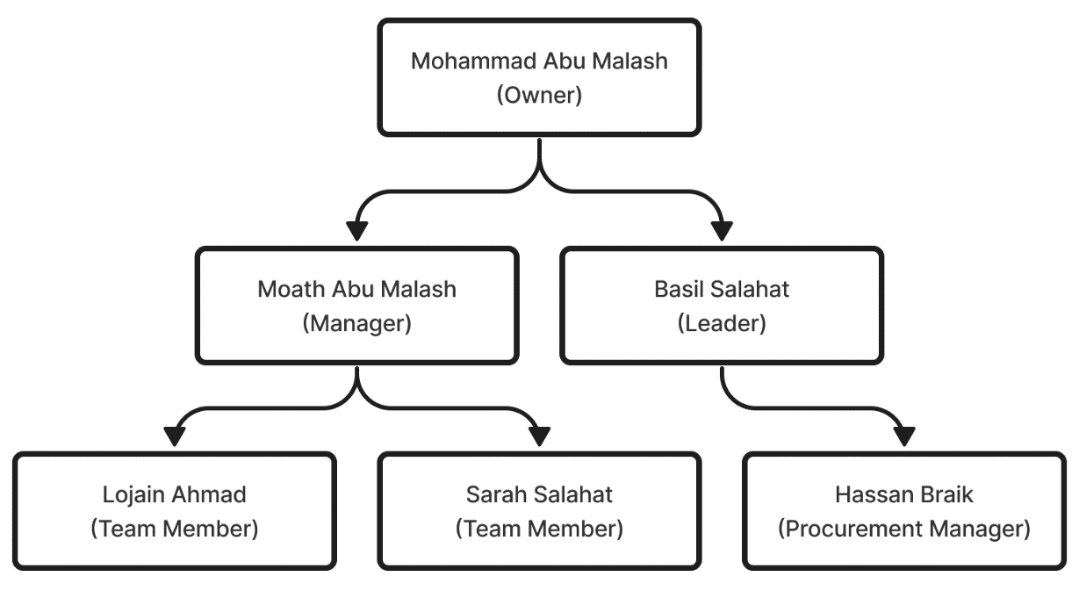
Figure 1 Project Organizational Chart

Management Strategy

Stakeholder Management Strategy for iStudent E-learning Platform
Prepared by: Basil Salahat
Date: 26 / 5 / 2023
Name | Level of Interest | Level of Influence | Potential Management Strategies
Mohammad Abu Malash | High | High | Mohammad Abu Malash is the CEO and the owner of the project he has a good look at the market and human sources with a lot of experience to stay on top of key projects as a businessman. Have a lot of short, face-to-face meetings and focus on achieving the financial benefits of the project.
Moath Abu Malash | Medium | low | Moath Abu Malash has a lot of great experience that any team member of his organization needs to work properly with the team.
Basil Salahat | High | Medium | Basil Salahat has the character that is completely necessary for a relationship man.
Table 2 Management Strategy

Chapter Two
Project Planning

Project Planning

Overview

Project Charter

The Project Kick-off Meeting

Collecting Requirements

Project Scope Statement

